Massey High School

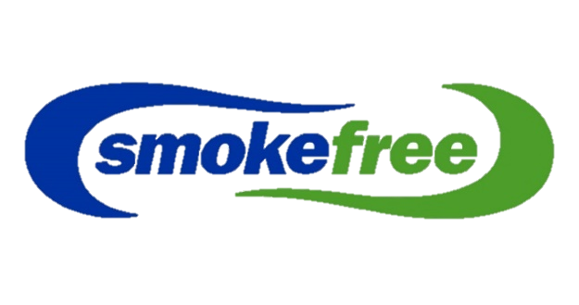

competitIon

**Create a Video, Song, Dance, Rap, Art or Game that encourages youth to say “NO” to smoking!**

**1st**

**1st**





**Highly Commended**

**Group**

**Individual**

**$2000 worth of prizes up for grabs!**

**Prizes across the three categories Include: Laptop, Headphones, Mouse Amazon Kindle or UE Boom and Cinema or NorthWest vouchers!**

**Enter as an Individual or as a Group of up to 4 people**

**To find out more talk to Makayla or Frances**

**Competition Closes: 29th September 3:10 PM**

