  - Massey High School competitIon information pack
BACKGROUND:
- Tobacco Smoking is a leading cause of preventable death, affecting individuals, whānau and the environment
- Youth (rangatahi) are a powerful voice to inspire healthy decisions and healthy environments.
- Rangatahi who lead an Auahi Kore(Smokefree) movement using creative ingenuity can decrease smoking rates and prevent any youth from starting smoking
- The benefits of entering the competition include: making a positive difference in your community, building skills for future career and job opportunities. All participants will receive a certificate that can aid the development of your curriculum vitae for careers and jobs.
YOUR MISSION:
- Create a smokefree message that promotes auahi kore amongst rangatahi, taking note of the data and information in this pack to help you shape your message
COMPETITION RULES
- You can enter only once either as an individual or as a group of up to 4 members
- Your parent or guardian must complete consent forms for your entry to be eligible
- Create the message using any of the following: dance, song, rap, meme, visual or written art, video, game or any other ways you feel appeal to rangatahi, Maori and Pacific communities
- You must ensure that your entry is suitable for uploading on social media platforms(i.e recording dance or drama, voice recording written art and songs and saving visual art as a GIF
- Your recording must be no longer 3 minutes and handed in on a USB
- You must not use language that would offend
HOW TO ENTER
- Waitemata DHB (the funder) and Sport Waitakere need your parent’s permission to showcase your work and capture your journey – a consent form completed and signed by your parent/guardian is required.
- To protect your creative work you can use a copyright symbol:©…..Your Name………2017. This means no one is allowed to copy it without getting permission from the creator e.g. © Glen Green 2017
Hand your completed
- A) Smokefree competition entry
- B) Entry form
- C) Consent form(signed by your parent/guardian)
to your form teacher by Friday 29 September 3pm. If you have any questions about this please ask Makayla or Frances
COMPETITION DATES:
- FRIDAY 29 SEPTEMBER 2017 3.00pm: Due Date for all entries: Include entry form and signed consent forms and
- MONDAY 16 OCTOBER-THURSDAY 19 OCTOBER 2017:School Wide judging of entries
- FRIDAY 20 OCTOBER 2017: Competition Winners Announced, Quizzes, and Celebratory lunch with all participants and the organising smokefree committee

PRIZES:
1st Individual:$1000:Laptop, Mouse, Headphones, Bag, Stationary or Food Voucher

1st Group: $800 Your choice between an Amazon Kindle or a UE boom for each person and North West Vouchers each if your group is smaller than 4 people

Highly Commended: 3 x Individual $50 Northwest or Cinema Vouchers Group 1x $100 North West or Cinema Vouchers

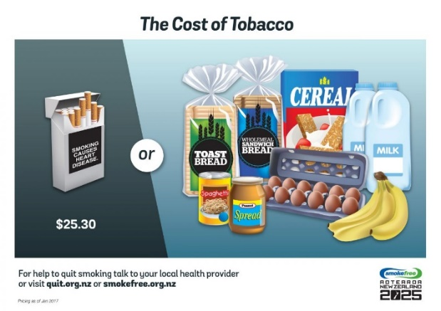

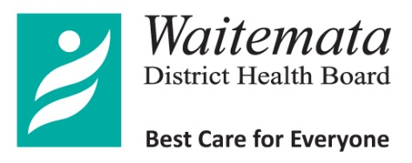
Communications
DHB Board Office
15 Shea Tce, Takapuna
North Shore City 0740
Private Bag 93-503, Takapuna
North Shore City
Telephone: 09 486 8920 ext 2120
Facsimile: 09 442 7260

CONSENT FOR USE OF visual and Written art & /or AUDIO &/OR VIDEO RECORDING/
Date:_________________________

I ____________________________am aware, as the parent/ caregiver of ________________________________, that he/she appears in an audio/visual video recording or has created visual or written art that is entered in the Massey High School / Waitemata DHB Smokefree Competition

I _______________________ give permission as the parent/caregiver of ________________ for the same audio/visual video recording or visual or written art-+ entered by him/her in the Massey High School/ Waitemata DHB Smokefree Competition to be used by the DHB online and via social media for staff and general public consumption.

I also give permission for this same material to be offered by the Waitemata DHB for use by various media agencies as part of any media package that might be created in a bid to promote DHB Smokefree initiatives.

In doing so I give my permission for _________________________ be publicly identified and acknowledged as the creator of any such work.

I understand that Waitemata DHB, its Board members, its associated companies and services, and its subsidiaries take no responsibility whatsoever for the publication or subsequent use of the material obtained by any third party without permission by any third party, and therefore cannot be held accountable for any such use should it occur.

Name :__________________________________________________( in full including middle names)

Date: __________________________

Signature: ____________________________________

Address: ______________________________________________________________________________________

______________________________________________________________________________________

City: ______________________________________

Phone (home) _____________________(work) ________________ (mobile)___________________

Email: ___________________________________________________________________________

CONSENT TO CAPTURE & USE PHOTOGRAPHS & VIDEOGRAPHY

Date: Project: Massey High School Smoke-free School Competition funded by the Waitemata District Board

STUDENT’S INFORMATION

First Name: _______________________________ Surname: _____________________________________

First Name: _______________________________ Surname: _____________________________________

- I give permission to HEALTHY FAMILIES WAITAKERE to take photographs, sound recordings and/or video footage (content) of each of the children named above (the Child) at, around, in front of or in relation to the SPORT WAITAKERE-HEALTHY FAMILIES WAITAKERE and WAITEMATA DHB collaborative project.

- I give permission for SPORT WAITAKERE-HEALTHY FAMILIES WAITAKERE and WAITEMATA DHB to use the content to showcase the process of engagement and conducting the competition. The content may be presented to WAITEMATA DHB and SPORT WAITAKERE-HEALTHY FAMILIES WAITAKERE Stakeholders for the purposes of encouraging our populations to become smoke-free and sharing learnings of this project. This may involve reproducing, publishing (including on Facebook and other social media sites), communicating, distributing, exhibiting, editing and otherwise use the content as it sees fit (without any limits as to medium, format, time or geography).

- No sums or royalties are payable by SPORT WAITAKERE-HEALTHY FAMILIES WAITAKERE and WAITEMATA DHB to me or the Child in connection with the content or its use.

The following consent and undertakings are given by me both personally and for and on behalf of the child as their parent or legal guardian:

I ________________________________________ parent/guardian of ___________________________ give permission for the conditions outlined above.

Signature: ____________________________ Date: ________________________________

Phone: ________________________________ Email: _______________________________________

ENTRY FORM MASSEY HIGH SCHOOL SMOKEFREE COMPETITION
Please complete the form with your choice of prizes to be in to win!

Individual Name___________________________________Form Class____________ Year ____________  Email:  1st prize: Laptop, Mouse, Headphones, Bag, and please choose either  Stationary Food Voucher | Highly commended individual and group  Please choose either vouchers:  Northwest  Or  Cinema
Group 1st prize UE Boom or Amazon Kindle
 |  |  |  | Tick either
Name | Form Class | Year | Email | UE Boom | Kindle

CREATING YOUR SMOKEFREE MESSAGE
- To support the development of your auahi kore message we encourage you to consider the following information
SURVEY DATA
A smokefree survey of 289 Massey High School Students was conducted in Term 2 2017 to understand current attitudes towards smoke-free behaviours.

massey high school competitIon

JUDGING CRITERIA

The following criteria will be used to judge all competition entries

Criteria | Possible Points | Points  Awarded
Impact  Challenges our emotions, inspires people who smoke to think about how they can stop and includes useful facts | 30
Relates to West Auckland Youth audience  Includes information on where to go for support / smoke -free services | 30
Clear message  Use of simple language and facts | 20
Creativity  Creative use of existing and/or new ideas into a powerful message | 20
Total Points: | 100

